BUILDING FLASK APPLICATION-PART 3

|  |  |
| --- | --- |
| DATE | 21 October 2022 |
| TEAM ID | PNT2022TMID30496 |
| PROJECT NAME | Real time communication system powered by AI specially abled |

**Building Flask Application -Part 3**

Duration: 0.5 Hrs Skill Tags:

Each frame is taken from the camera and processed and sent to the model for prediction. As discussed image undergoes different processing steps to meet model requirements to get predictions.

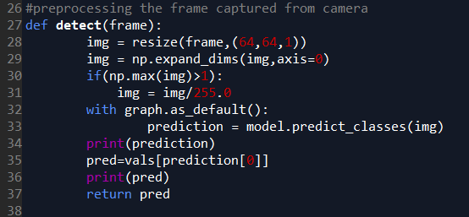

This below in the snippet for calling video feed from the HTML page.

